Q1) For each host, record the percentage of packets sent that resulted in a successful response. Record also the minimum, average, and maximum round trip times for the packets that resulted in a response

|  |  |  |  |  |
| --- | --- | --- | --- | --- |
| Website | Successful Percentage | Min RTT | Average RTT | Max RTT |
| www.csail.mit.edu | 100 | 4.446 | 10.140 | 21.5 |
| [www.berkeley.edu](http://www.berkeley.edu) | 100 | 198.646 | 258.697 | 330.078 |
| www.usyd.edu.au | 100 | 144.812 | 218.010 | 342.852 |
| www.kyoto-u.ac.jp | 100 | 82.931 | 89.931 | 95.794 |

Q2) Based on the above results, the first website has the shortest response time, followed by Kyoto university, UYSD university and lastly Berkeley university. This is because the time it takes to route to MIT’s server is the shortest, going through the fewest(6) hops while Berkeley uses 18 hops to get through, and had 6 timed out tries before it was able to find a route. Some of these Request Timed out could also be due to the router blocking ping and traceroute requests, resulting in a lack of response.

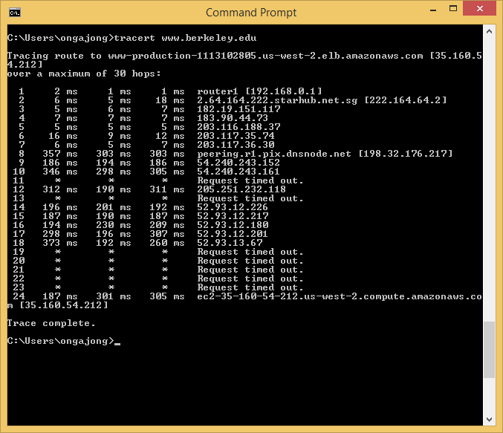

Q3) Repeat the exercise using packet sizes of 56, 512, and 1024 bytes. Record the minimum, average, and maximum round trip times for each of the packet sizes. Why are the minimum round-trip times to the same hosts different when using 56, 512, and 1024-byte packets?

|  |  |  |  |  |  |
| --- | --- | --- | --- | --- | --- |
| Website | Data byte packets | Successful Percentage % | Min RTT | Average RTT | Max RTT |
| [www.csail.mit.edu](http://www.csail.mit.edu) | 56 | 100 | 6.989 | 10.612 | 18.136 |
|  | 512 | 100 | 7.320 | 12.428 | 20.898 |
|  | 1024 | 100 | 6.989 | 8.952 | 15.316 |
| www.berkeley.edu | 56 | 100 | 193.327 | 213.151 | 312.383 |
|  | 512 | 100 | 198.151 | 269.138 | 399.293 |
|  | 1024 | 100 | 194.971 | 226.211 | 351.975 |
| www.usyd.edu.au | 56 | 100 | 240.215 | 281.354 | 456.286 |
|  | 512 | 100 | 240.391 | 328.163 | 424.759 |
|  | 1024 | 100 | 241.306 | 339.753 | 449.874 |
| [www.kyoto-u.ac.jp](http://www.kyoto-u.ac.jp) | 56 | 100 | 85.422 | 88.464 | 99.670 |
|  | 512 | 100 | 85.286 | 86.914 | 88.648 |
|  | 1024 | 100 | 85.561 | 89.632 | 95.296 |

Bandwidth is the maximum number of bits per second in order to guarantee reasonable level of reliability. Packet is single unit and considered to be transferred over small time. A larger packet will take long time to transfer resulting into more collisions at Layer 1. The medium of transmission transfer electrons based on their mobility. This restriction affects the rate of data transfer over them. A large packet would mean others won’t get chance to use the transmission line. Apart from this, if packet size is large in high probability it will get dropped at queue or get fragmented (which is more computationally intensive then retransmittin gin form of small packets) .

Q4) Record the percentage of the packets sent to [www.wit.ac.za](http://www.wit.ac.za) that resulted in a successful response. What are some possible reasons why you may not have received a response? (Be sure to check the host in a web server)

0 were received. 100% packet loss.

This website had blocked ping requests for security reasons

Q5) Trace route is a utility that records the route (the specific gateway computers at each hop) through the Internet between your computer and a specified destination computer. It also calculates and displays the amount of time each hop took.

When entering the trace route command, the utility initiates the sending of a packet (using the Internet Control Message Protocol or ICMP) , including in the packet a time limit value (known as the “time to live” (TTL) that is designed to be exceeded by the first router that receives it, which will return a time exceeded message. This enables traceroute to determine the time required for the hop to the first router. Increasing the time limit value, it resends the packet so that it will reach the second router in the path to the destination, which returns another Time Exceeded message and so forth. Traceroute determines whether the packet has reached the destination by including a port number that is outside the normal range. When it’s received, a Port Unreachable message is returned, enabling traceroute to measure the time length of the final hop. As the trace routing progresses, the records are displayed for you hop by hop.

Q 6 and 7

From Amsterdam:

Tracing route to 213.214.121.210 over a maximum of 30 hops.

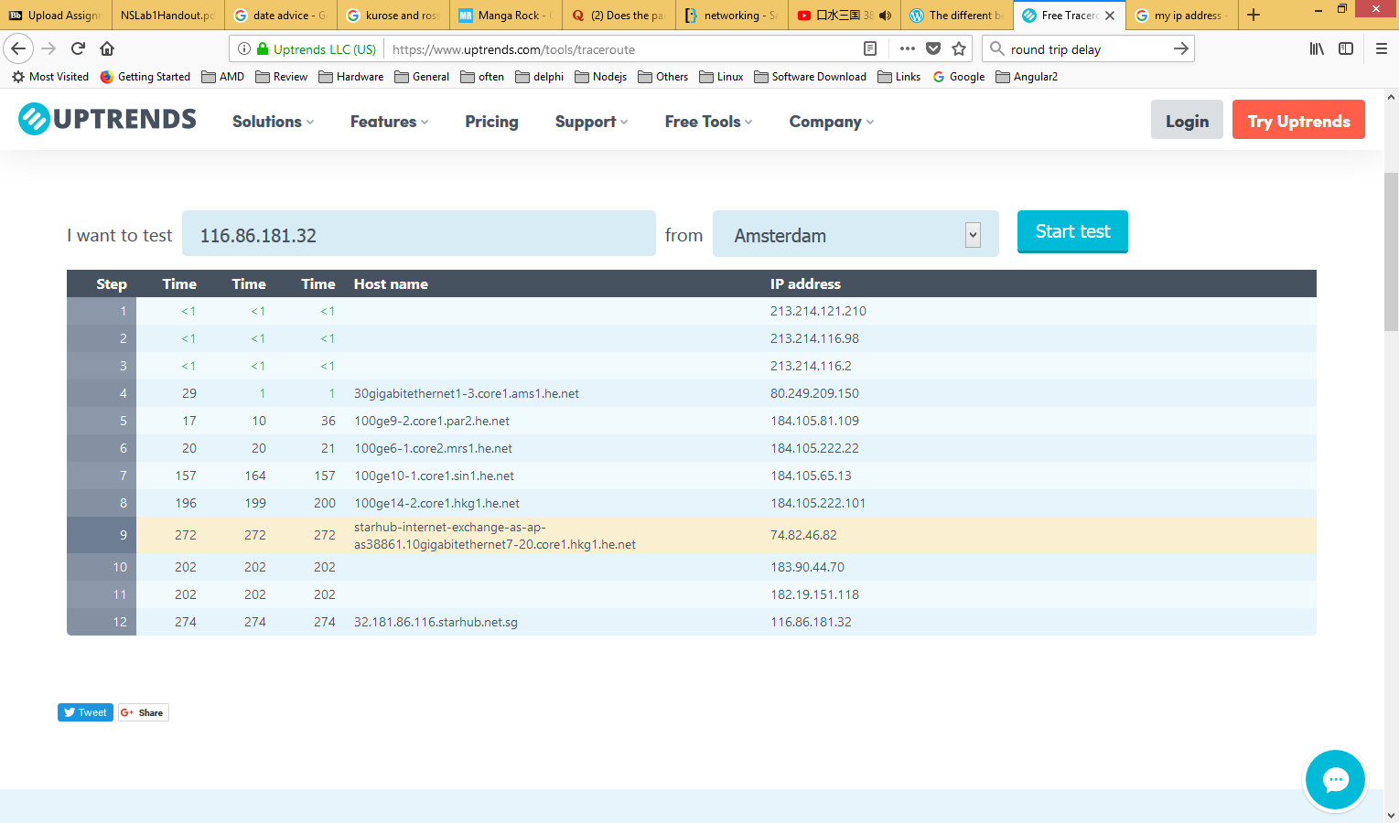

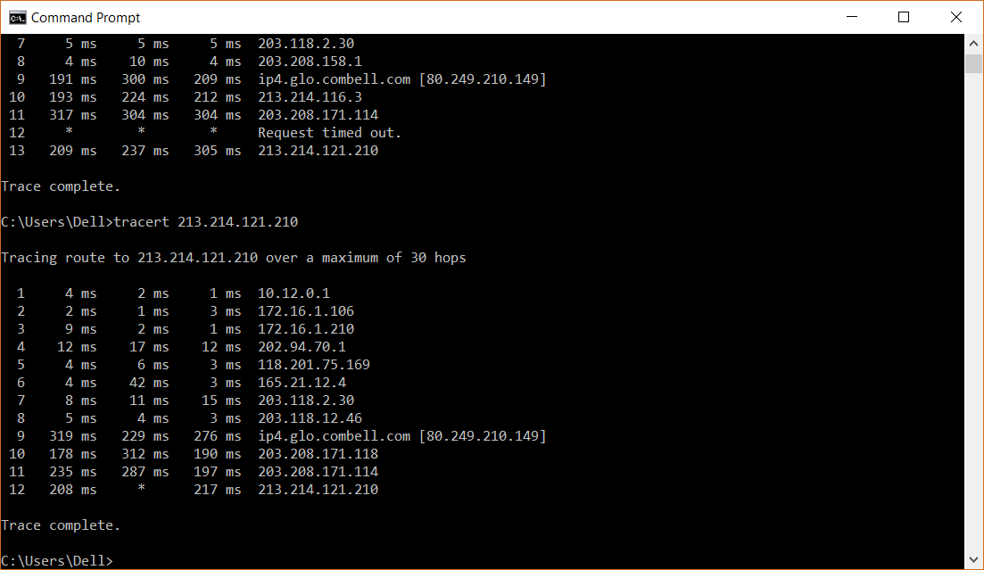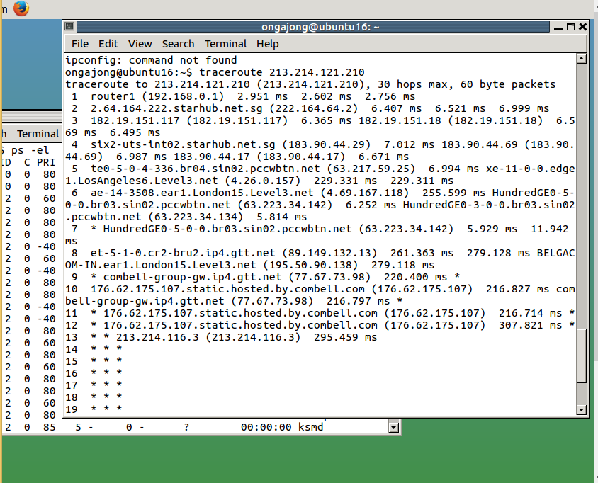Both outputs show that traceroute goes through a few local servers before going to router 118.201.75.X where X is the port number. The traceroute takes an average of 12 to 13 hops to get from one end to another.

The routes travelled are not the same. They first go through local servers (213.214.121.X from Amsterdam) before going to a regional net (118.201.75.169, 165.21.12.4 belongs to Singnet, 203.118.X.X belongs to Starhub IP and Internet Exchange,) moving across to another ISP (ip4.glo.combell.com at 80.249.210.149 belongs to Amsterdam Internet Exchange BV) before routing through a remote local server.

From New York

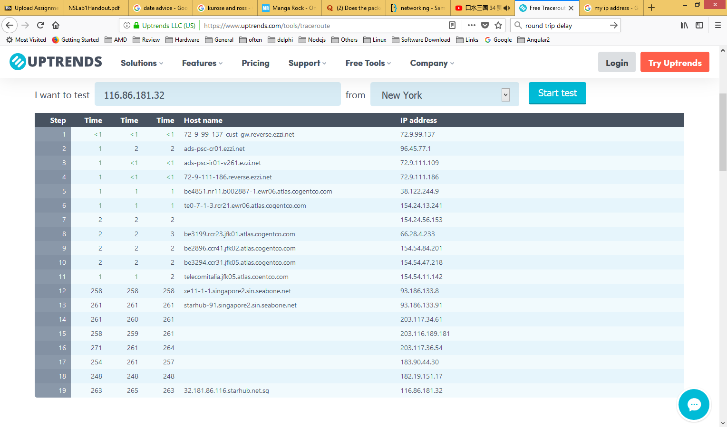

To New York

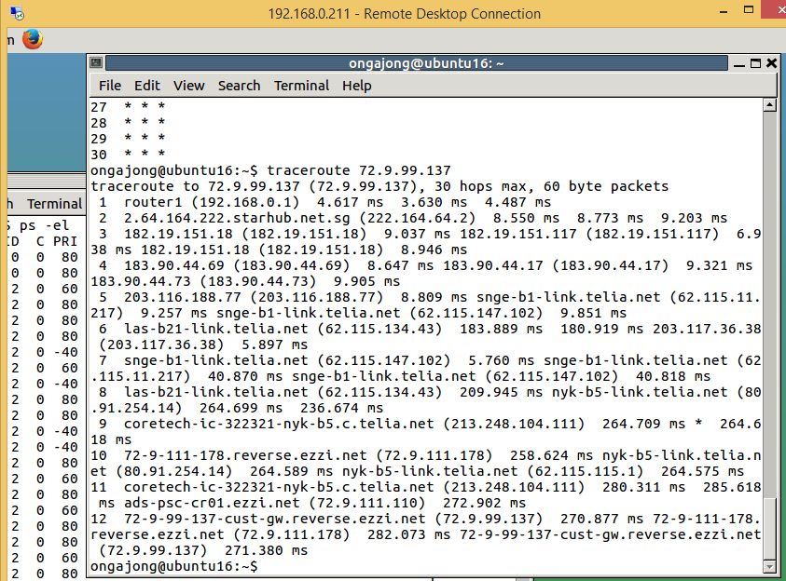

It took more hops from New York to Singapore than vice versa. While it took five hops to reach an international exchange point from local address, it needed 11 hops before the IP Address from New York could reach an IXP. This may be due to more local routing within America compared to Singapore.

From Tokyo

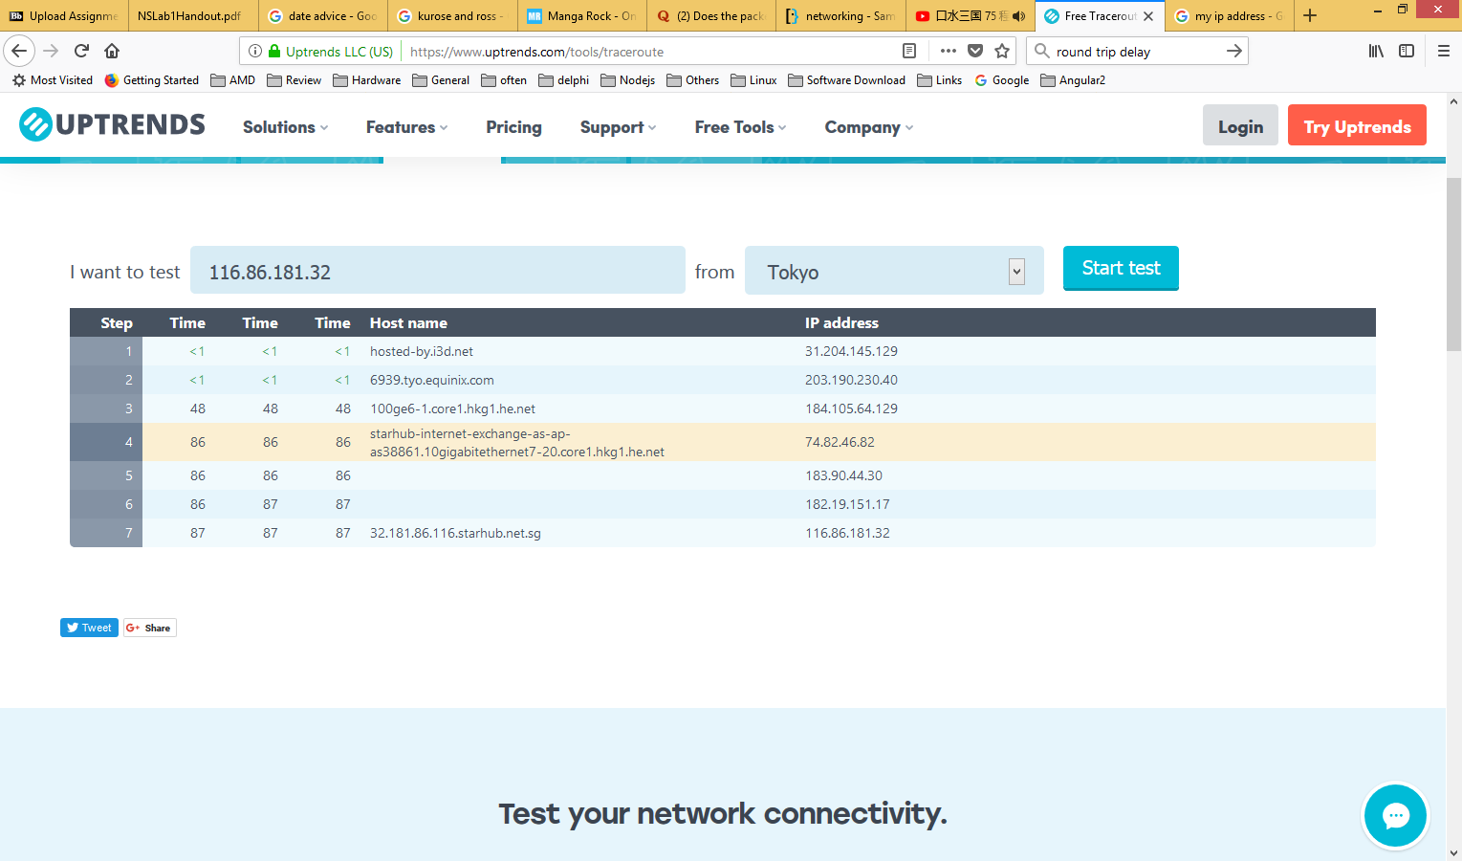To Tokyo

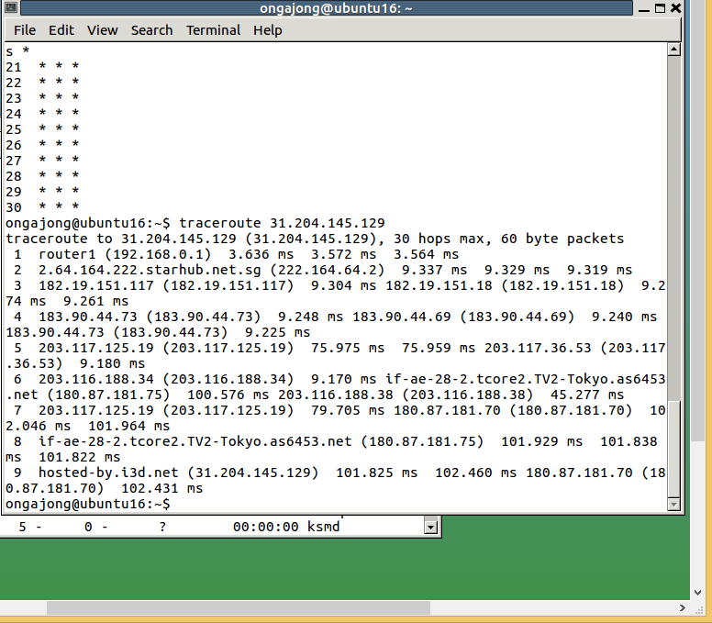In this case, there were more hops taken from my IP to the IXP than from the IXP to my IP address. This may be due to there being a greater amount of internal routing from within Singapore to Tokyo as compared to routing from Tokyo. The time taken is also greater due to the number of hops being larger to Japan.

Overall Conclusion

It takes a greater number of time to travel from a remote address to my local IP address compared to the opposite for New York and Amsterdam but not Tokyo. Furthermore, there is usually a greater number of hops relative to distance between remote and personal IP address.

Q7: Trace route works by sending a package to the destination IP with TLL = 1. The receiving router decrements TTL and because TTL = 0 discards the package and returns TTL exceeded. Traceroute sends a package to the destination IP with TTL2 and so on until the package reaches its destination.

When a router receives a packet, its only mission is to send it forward to the next hop as soon as possible. The router makes a decision based on a routing table. Checking the table and making a decision is called process switching, so there are other methods such as fast switching to speed it up.

When the destination of a traceroute is a host, on the first packet the routers will use the traditional way to know where is the destination, but after that in the next packets the routers will use fast switching or CEF. From origin to destination there will be a fixed path. When the destination of a trace route is a router, the intermediate routers will do the same as before, but the destination router won’t do it because there is no next hop. So the destination router will do process switching. The reason why routers change is because a destination router may have two or more connections to different ISPs and the connections are doing load balancing.

Load balancing means that to avoid a single connection getting overloaded until the router uses the next one, it uses a mechanism as a round-robin to evenly distribute the traffic among all its connections. So you will always have a different path for both directions.